
Project Name
PERSONAL FINANCE MANAGER
(CLI-Based Multi-User System)
Name: Piyush Raj
Roll Number: 2330383
Branch: Electronics and Computer Science Engineering
College Name: Kalinga Institute Of Industrial Technology Bhubaneswar
Intern Id : 8766
Internship Company: Navodita Infotech
Internship Domain: Python

Objective
The objective of this project is to design and develop a command-line based Personal Finance Manager using Python that enables users to efficiently track and manage their financial activities. The system allows multiple users to securely create accounts, record their income and expenses, and maintain individual financial records. It also provides analytical features such as expense visualization and automated financial recommendations to help users understand their spending patterns and improve financial decision-making.

Problem Statement
Personal Finance Manager: Build a personal finance manager that helps users track their expenses, income, and budgeting, providing visualizations and recommendations.

Tools & Technologies
Python, CSV, OS module, Matplotlib

Features
1. Multi-User Authentication System
Allows multiple users to create accounts and securely log in using unique usernames and passwords.
2. Unique Username Validation
Prevents duplicate usernames by checking existing records during signup.
3. User-Specific Data Storage
Each user has a separate CSV file to store their financial data, ensuring privacy and data isolation.
4. Income Management
Users can add multiple sources of income, allowing better tracking of total earnings.
5. Expense Tracking with Categories
Expenses can be recorded under different categories such as Food, Travel, Bills, and Others.

6. Multiple Expense Entry Support
Users can enter multiple expenses in a single session for convenience.
7. Dynamic Balance Calculation
The system automatically calculates the remaining balance as the difference between total income and total expenses.
8. Transaction History Display
Displays all past transactions (income and expenses) in an organized format.
9. Data Persistence Using CSV Files
Financial data is saved in CSV files, allowing users to access their data even after restarting the program.
10. Expense Visualization
Generates graphical representations (pie charts) of expenses using Matplotlib for better understanding of spending patterns.
11. Smart Financial Recommendations
Provides suggestions based on spending behavior (e.g., overspending alerts or saving advice).
12. Data Deletion Options
Users can delete specific transactions or clear all their financial data.
13. Simple and User-Friendly Interface
Uses a command-line interface (CLI) that is easy to understand and operate.
14. Error Handling and Input Validation
Handles invalid inputs (like wrong data types or empty fields) to prevent crashes.
15. Modular Code Structure
The program is divided into functions, making it easy to understand, maintain, and extend.
Algorithm
1.Start
2. Signup/Login
3. Load data
4. Perform operations

5. Save
6. Exit
Code
import csv
import os
import matplotlib.pyplot as plt

transactions = []
current_user = None

# ---------- SIGNUP ----------
def signup():
print("\n==== Sign Up ====")
username = input("Create Username: ")
password = input("Create Password: ")

if username == "" or password == "":
print("❌ Fields cannot be empty!")
return

if os.path.exists("users.csv"):
with open("users.csv", "r") as f:
for row in csv.reader(f):
if row[0] == username:
print("❌ Username already exists!")
return

with open("users.csv", "a", newline="") as f:

csv.writer(f).writerow([username, password])
print("✅ Account created!")

# ---------- LOGIN ----------
def login():
global current_user

print("\n==== Login ====")
username = input("Username: ")
password = input("Password: ")

if not os.path.exists("users.csv"):
print("No users found.")
return False

with open("users.csv", "r") as f:
for row in csv.reader(f):
if row[0] == username and row[1] == password:
current_user = username
print(f"Welcome {username}")
return True

print("❌ Invalid login!")
return False

# ---------- FILE ----------
def filename():

return f"{current_user}_data.csv"

# ---------- LOAD ----------
def load_data():
global transactions
transactions = []

if os.path.exists(filename()):
with open(filename(), "r") as f:
for row in csv.reader(f):
transactions.append((row[0], float(row[1]), row[2]))

# ---------- SAVE ----------
def save_data():
with open(filename(), "w", newline="") as f:

csv.writer(f).writerows(transactions)
print("✅ Data Saved!")

# ---------- ADD ----------
def add_income():
try:
amt = float(input("Enter income: "))
transactions.append(("Income", amt, "None"))
except:
print("❌ Invalid input!")

def add_expense():

while True:
cat = input("Category (Food/Travel/Bills/Others or 'done'): ")

if cat.lower() == "done":
break
try:
amt = float(input("Amount: "))
transactions.append(("Expense", amt, cat.capitalize()))
except:
print("❌ Invalid input!")

# ---------- SHOW ----------
def show_balance():
inc = sum(t[1] for t in transactions if t[0]=="Income")
exp = sum(t[1] for t in transactions if t[0]=="Expense")
print(f"Balance: ₹{inc-exp:.2f}")

def show_transactions():
print("\n--- Transactions ---")
for i,t in enumerate(transactions):
print(f"{i+1}. {t}")

# ---------- DELETE ----------
def delete_data():
global transactions
print("\n1. Delete ALL\n2. Delete ONE")
ch = input("Enter choice: ")

if ch=="1":
transactions=[]
print("All data deleted!")
elif ch=="2":
show_transactions()

try:
idx=int(input("Enter index: "))-1
transactions.pop(idx)
print("Entry deleted!")
except:
print("Invalid index!")

# ---------- VISUAL ----------
def visualize():
data={}
for t in transactions:

if t[0]=="Expense":
data[t[2]]=data.get(t[2],0)+t[1]

if not data:
print("No data to visualize.")
return

plt.pie(data.values(), labels=data.keys(), autopct='%1.1f%%')
plt.title(f"{current_user}'s Expenses")
plt.show()

# ---------- RECOMMEND ----------
def recommend():

inc=sum(t[1] for t in transactions if t[0]=="Income")
exp=sum(t[1] for t in transactions if t[0]=="Expense")
if exp>inc:

print("⚠️ Overspending")
elif exp>0.7*inc:
print("⚠️ High spending")
else:
print("✅ Good financial condition")

# ---------- MAIN ----------
while True:
print("\n==== MAIN MENU ====")
print("1. Signup")

print("2. Login")
print("3. Exit")

ch = input("Enter choice: ")

if ch=="1":
signup()

elif ch=="2":
if login():
load_data()

while True:
print(f"\n==== {current_user}'s Dashboard ====")
print("1. Add Income")
print("2. Add Expense")
print("3. Show Balance")

print("4. Show Transactions")
print("5. Visualize Expenses")
print("6. Recommendation")
print("7. Save Data")
print("8. Delete Data")
print("9. Logout")

c = input("Enter choice: ")

if c=="1": add_income()

elif c=="2": add_expense()
elif c=="3": show_balance()
elif c=="4": show_transactions()
elif c=="5": visualize()
elif c=="6": recommend()
elif c=="7": save_data()
elif c=="8": delete_data()
elif c=="9": break
else: print("Invalid!")

elif ch=="3":
print("Goodbye!")
break

Outputs/Terminal Screenshots:-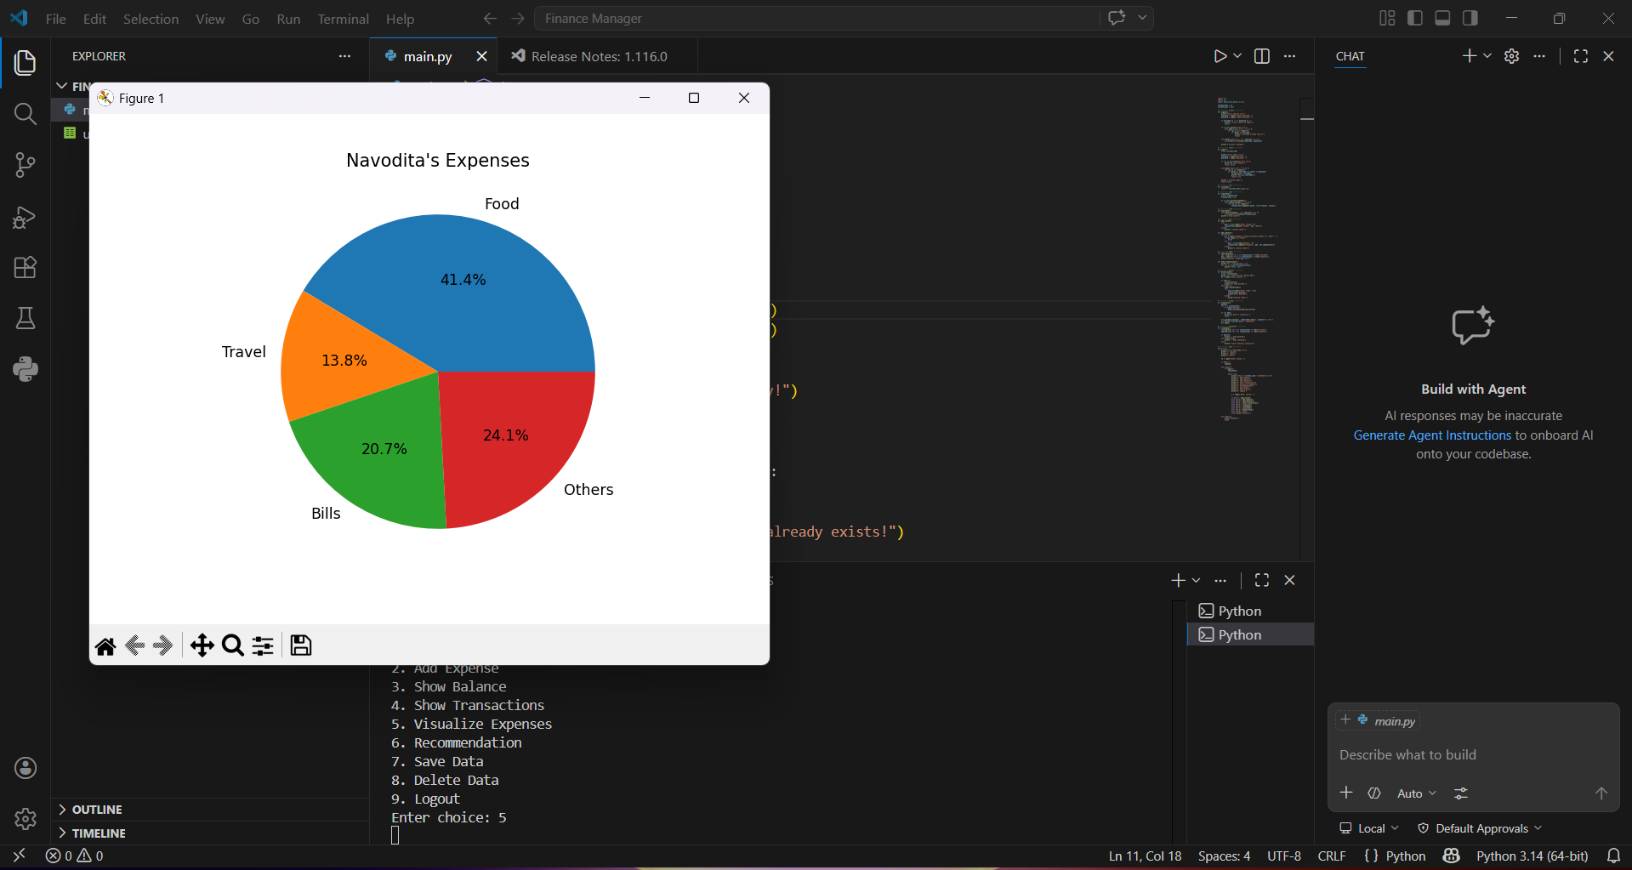

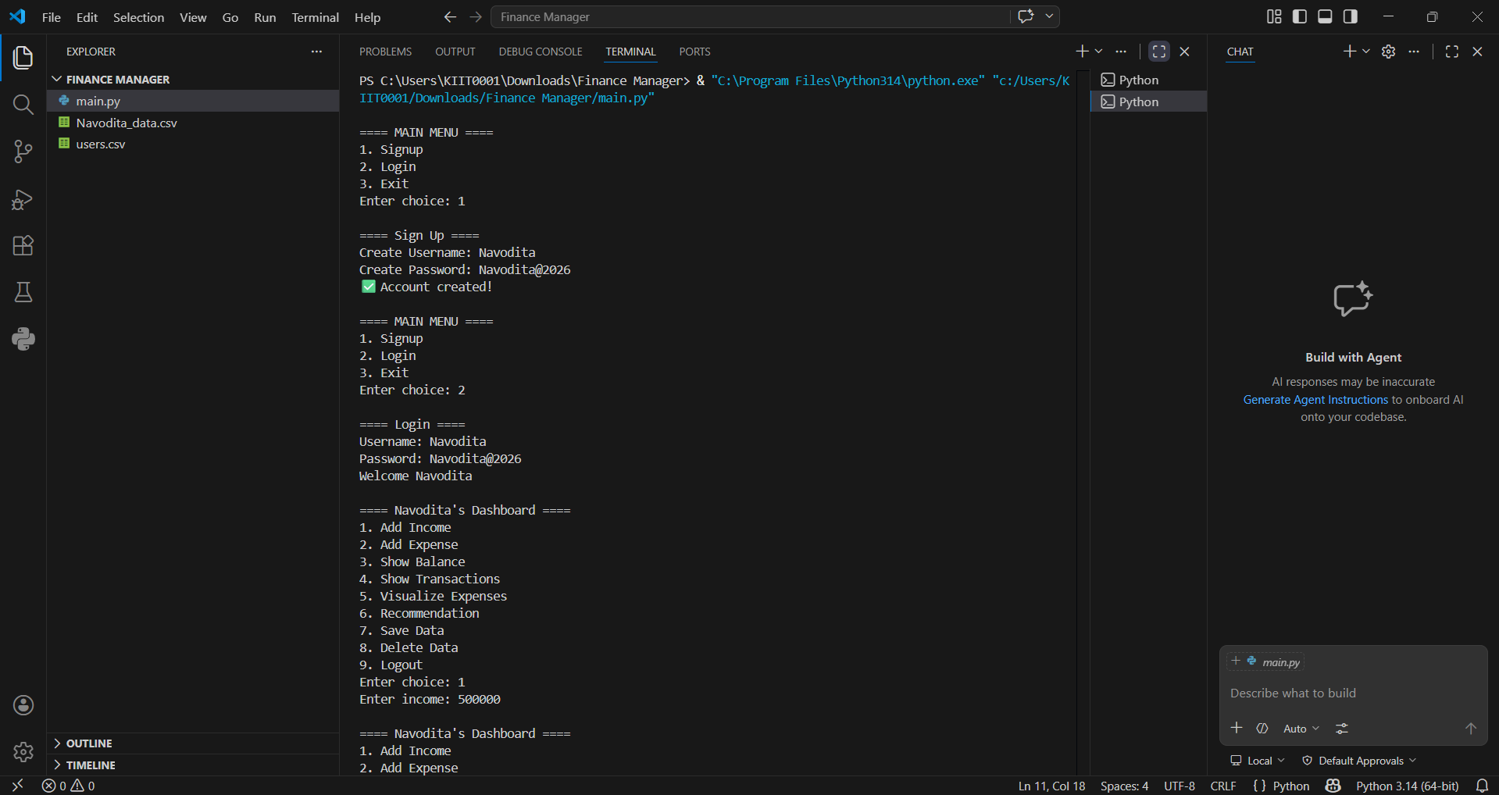

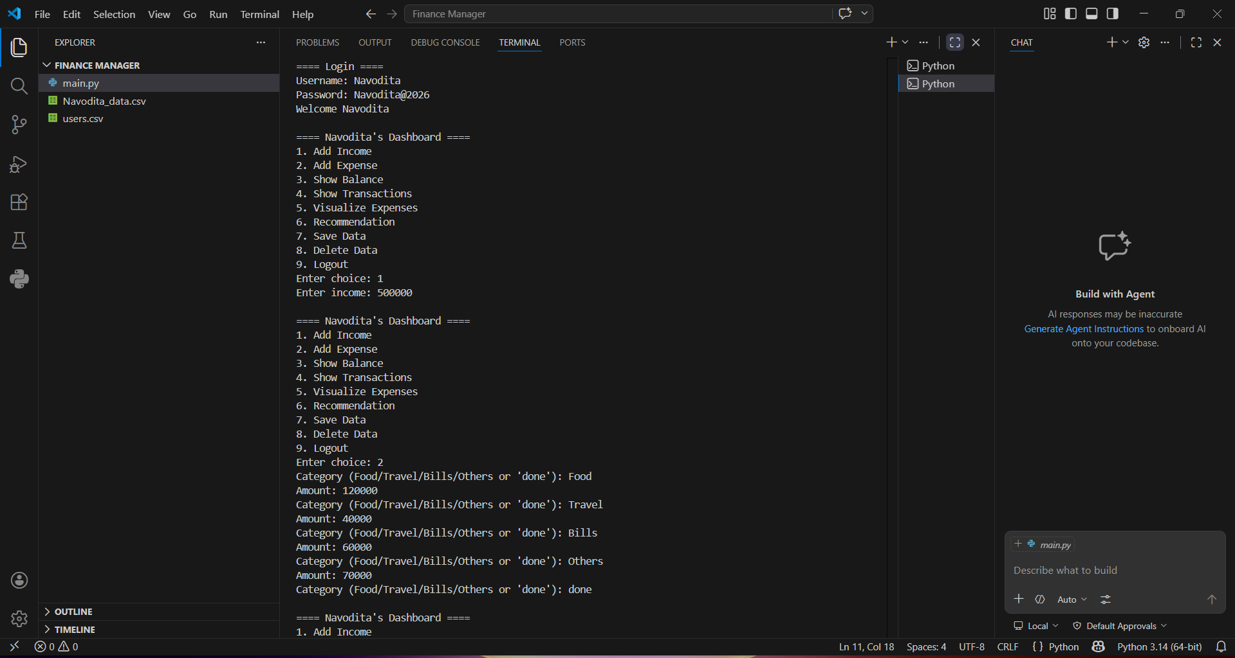

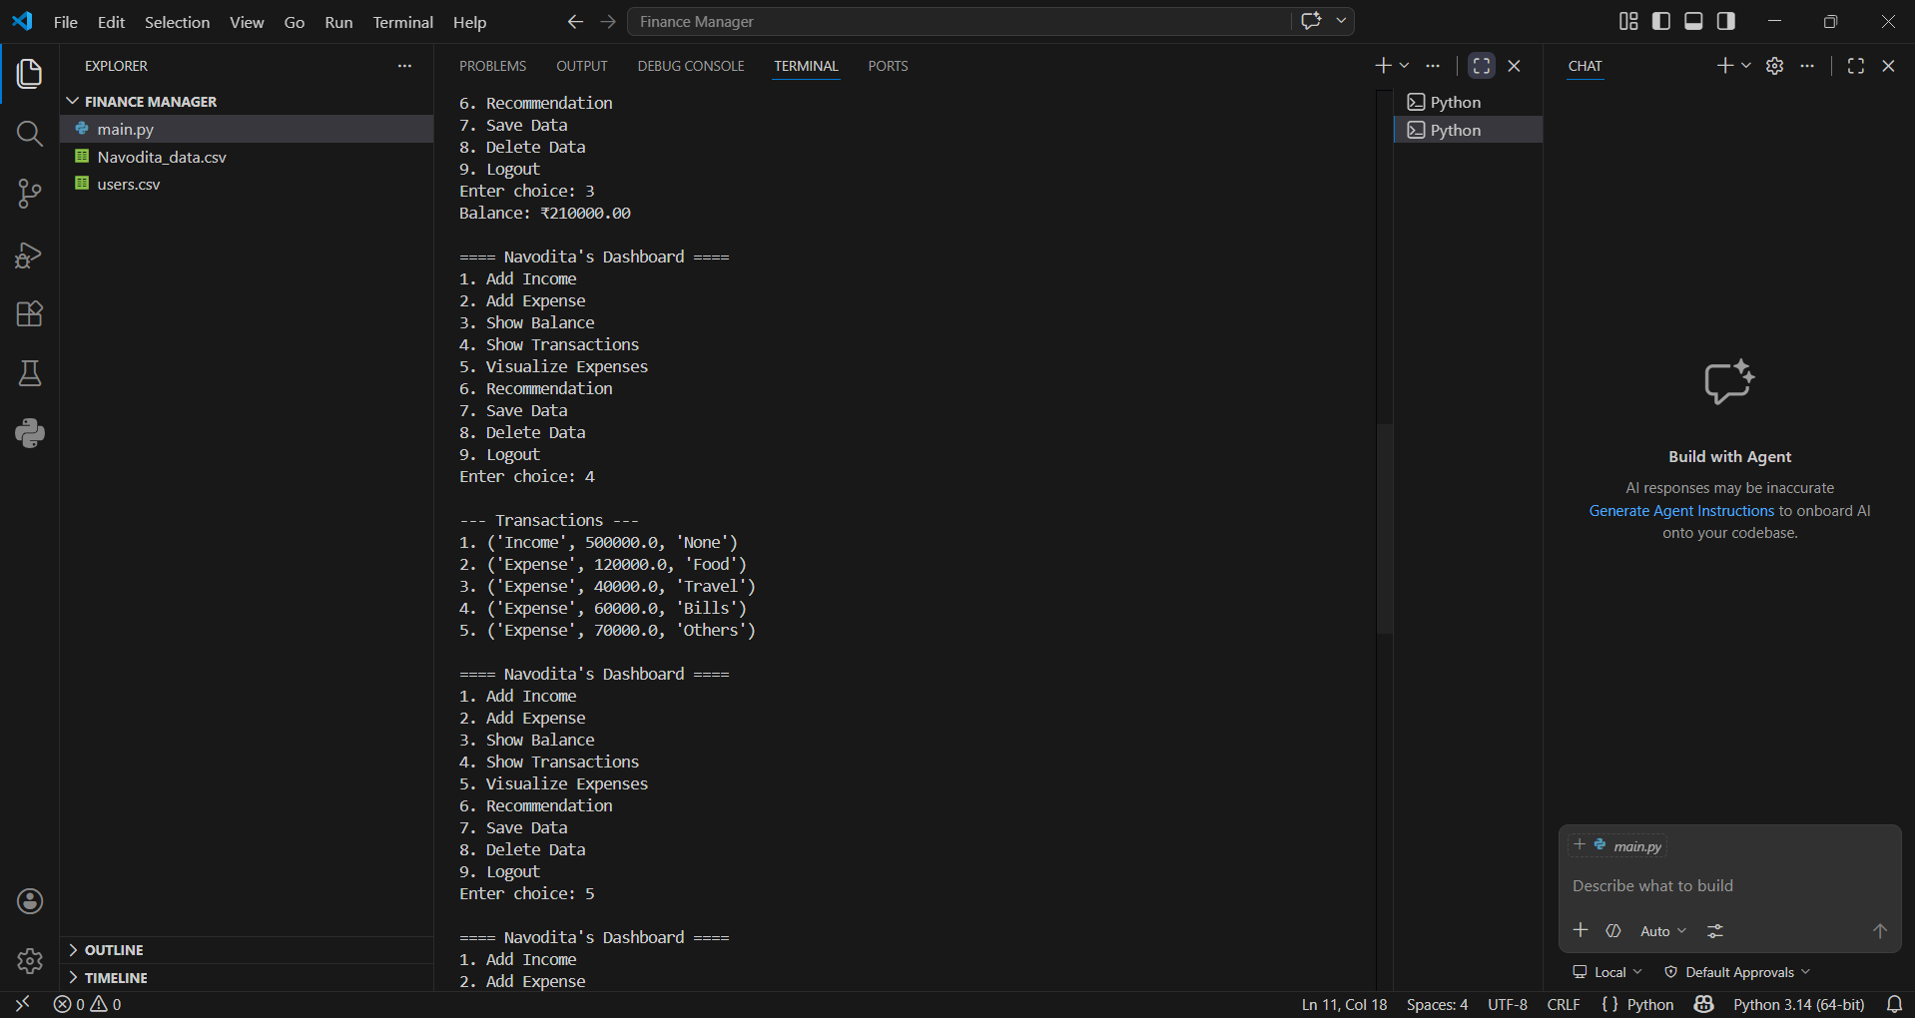

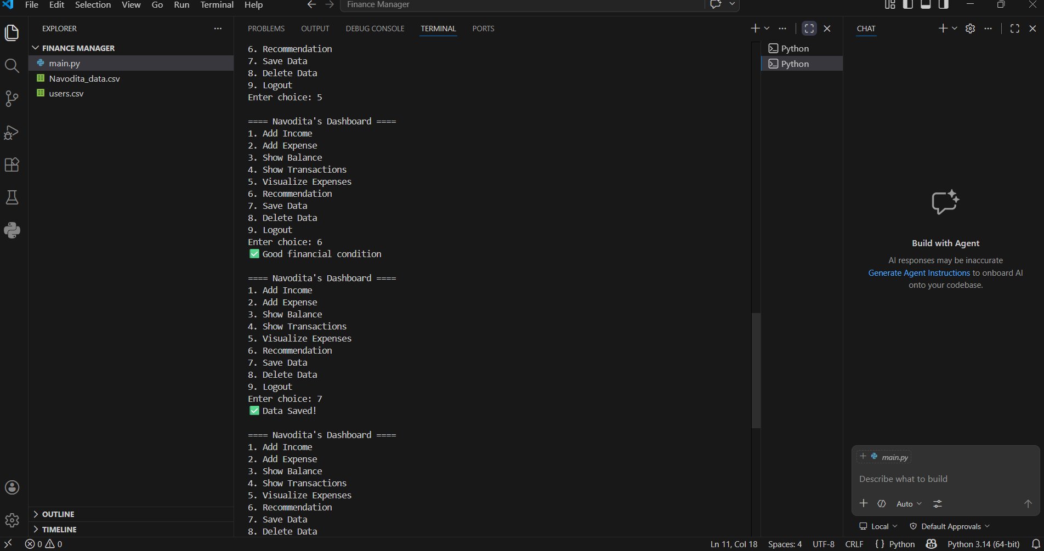

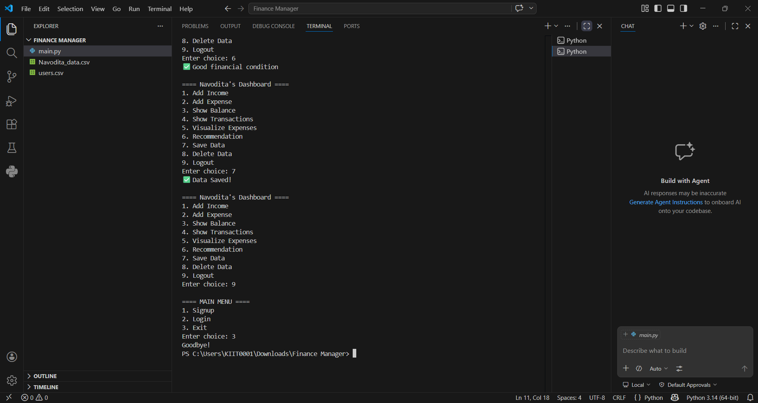

Code Screenshots
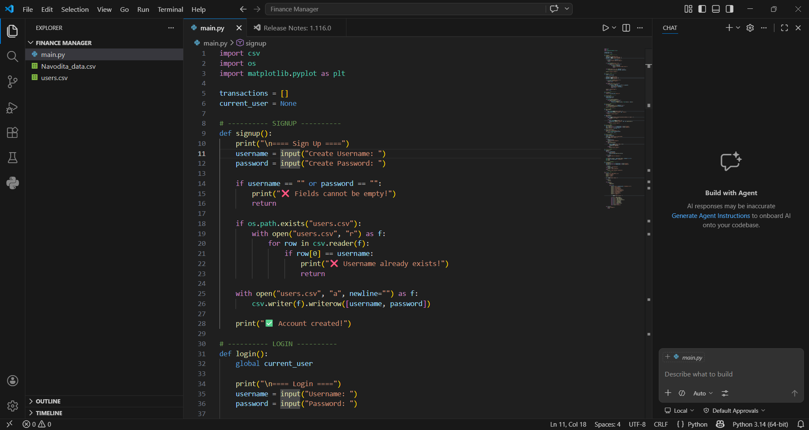
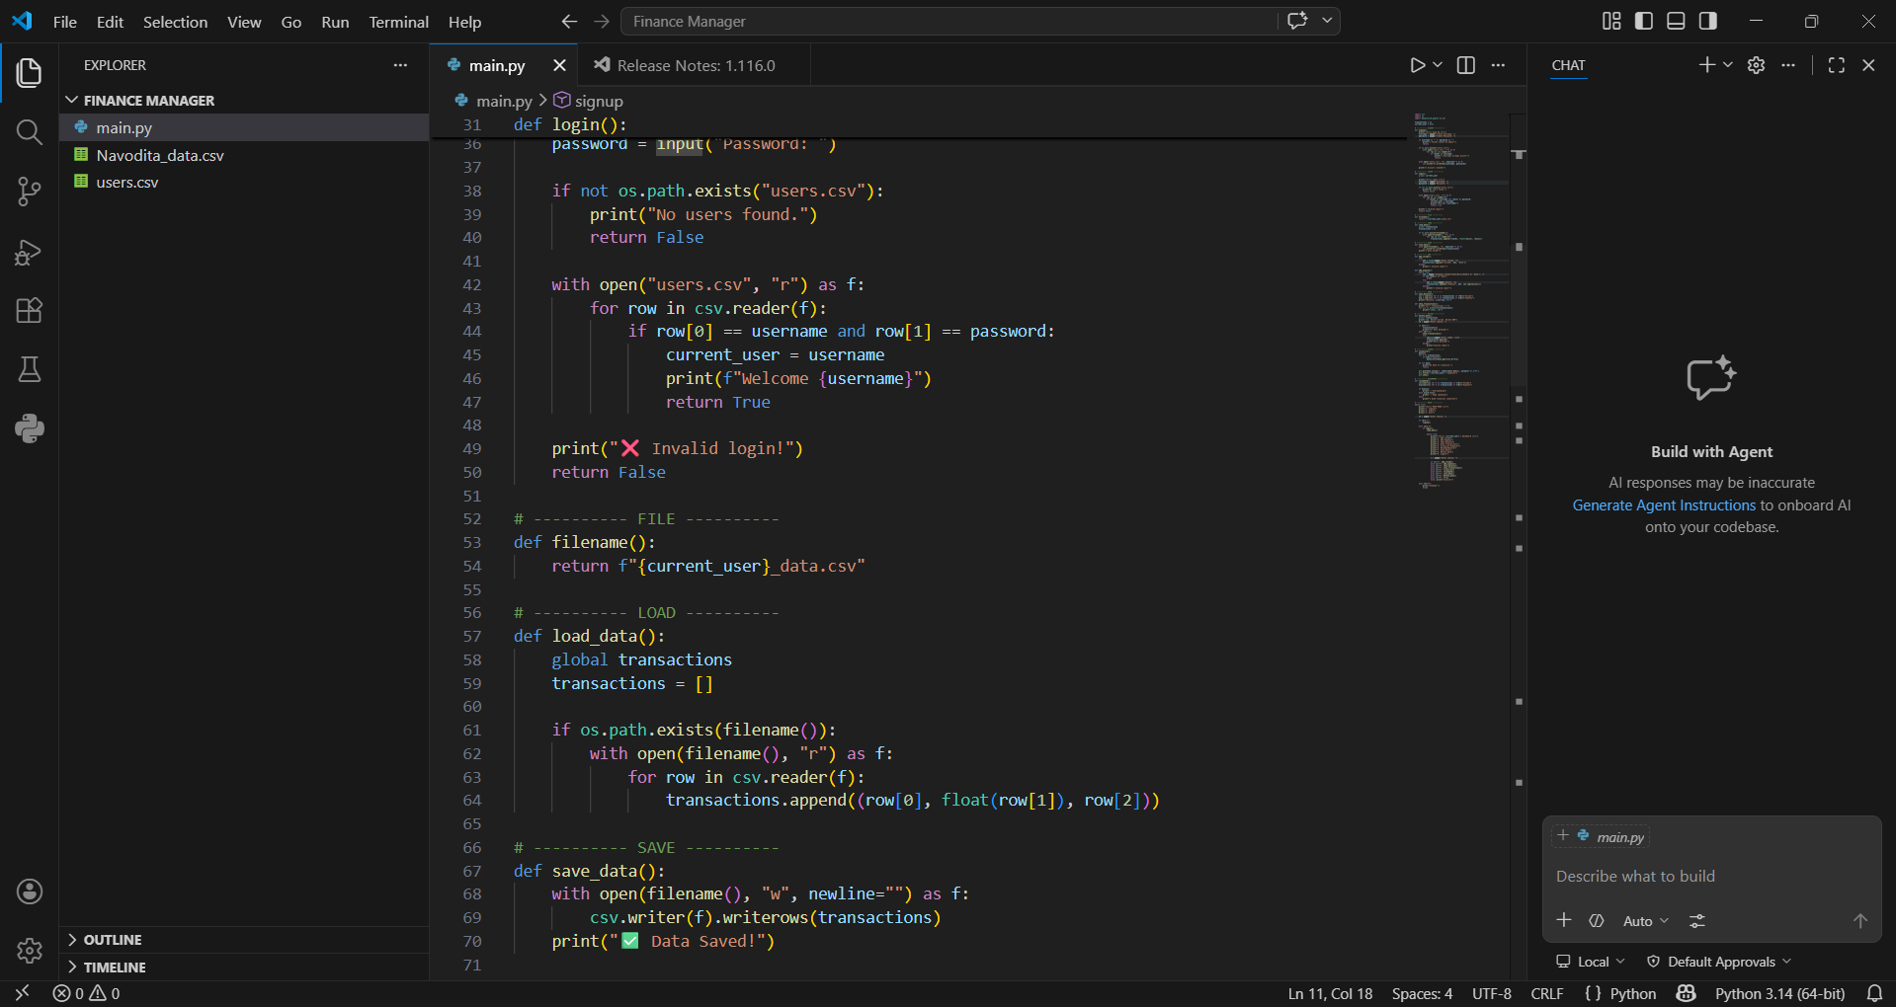

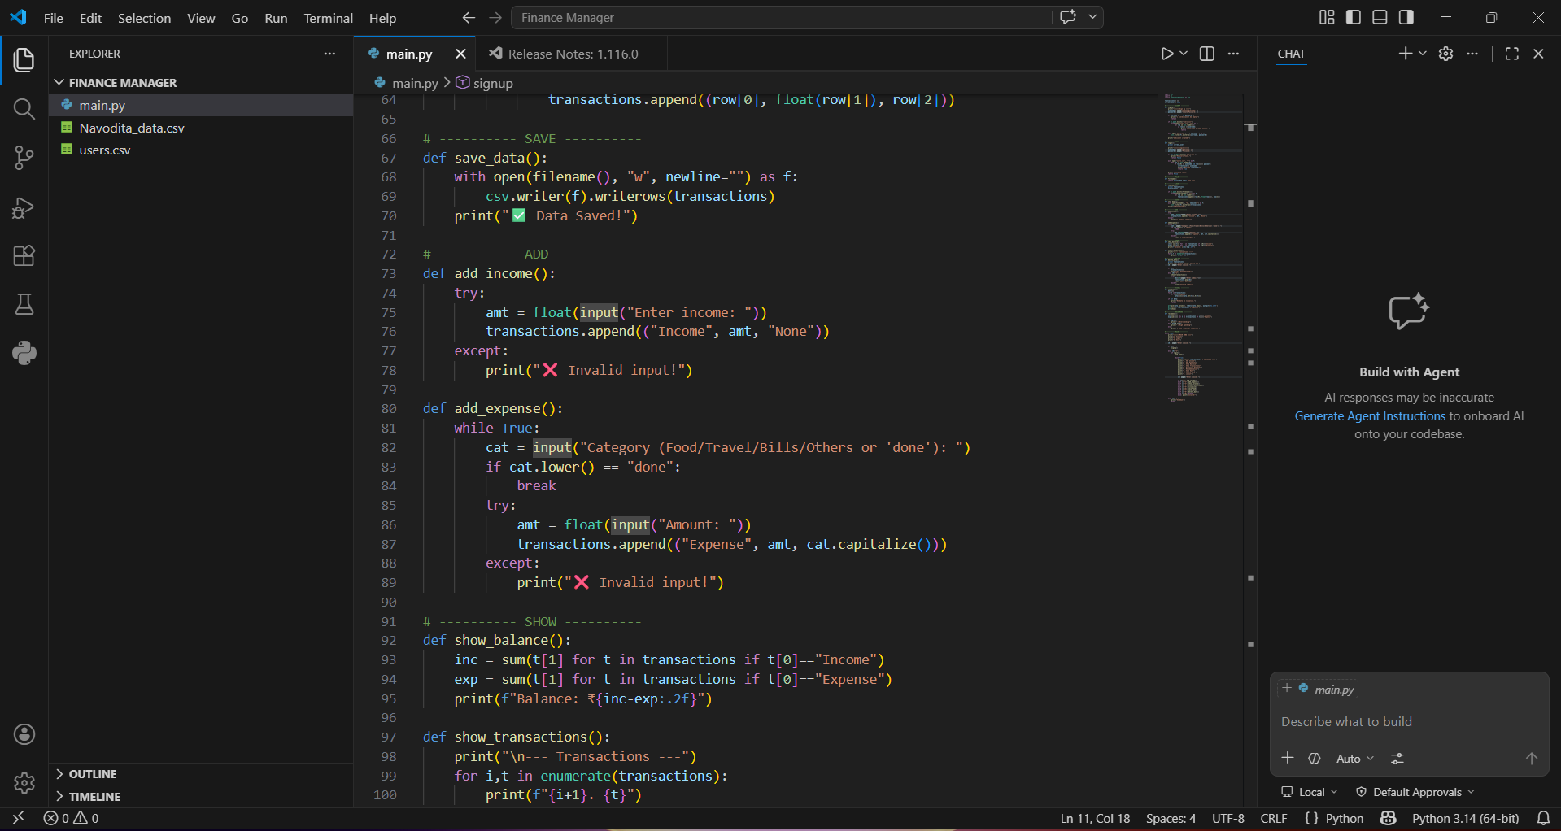
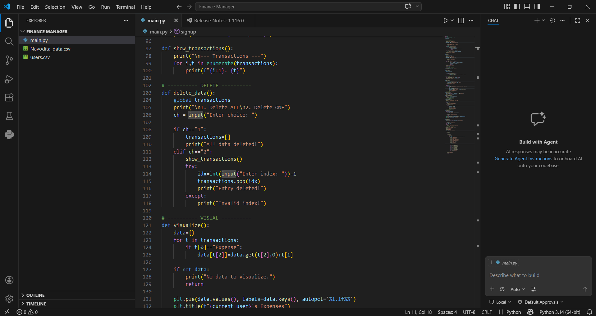

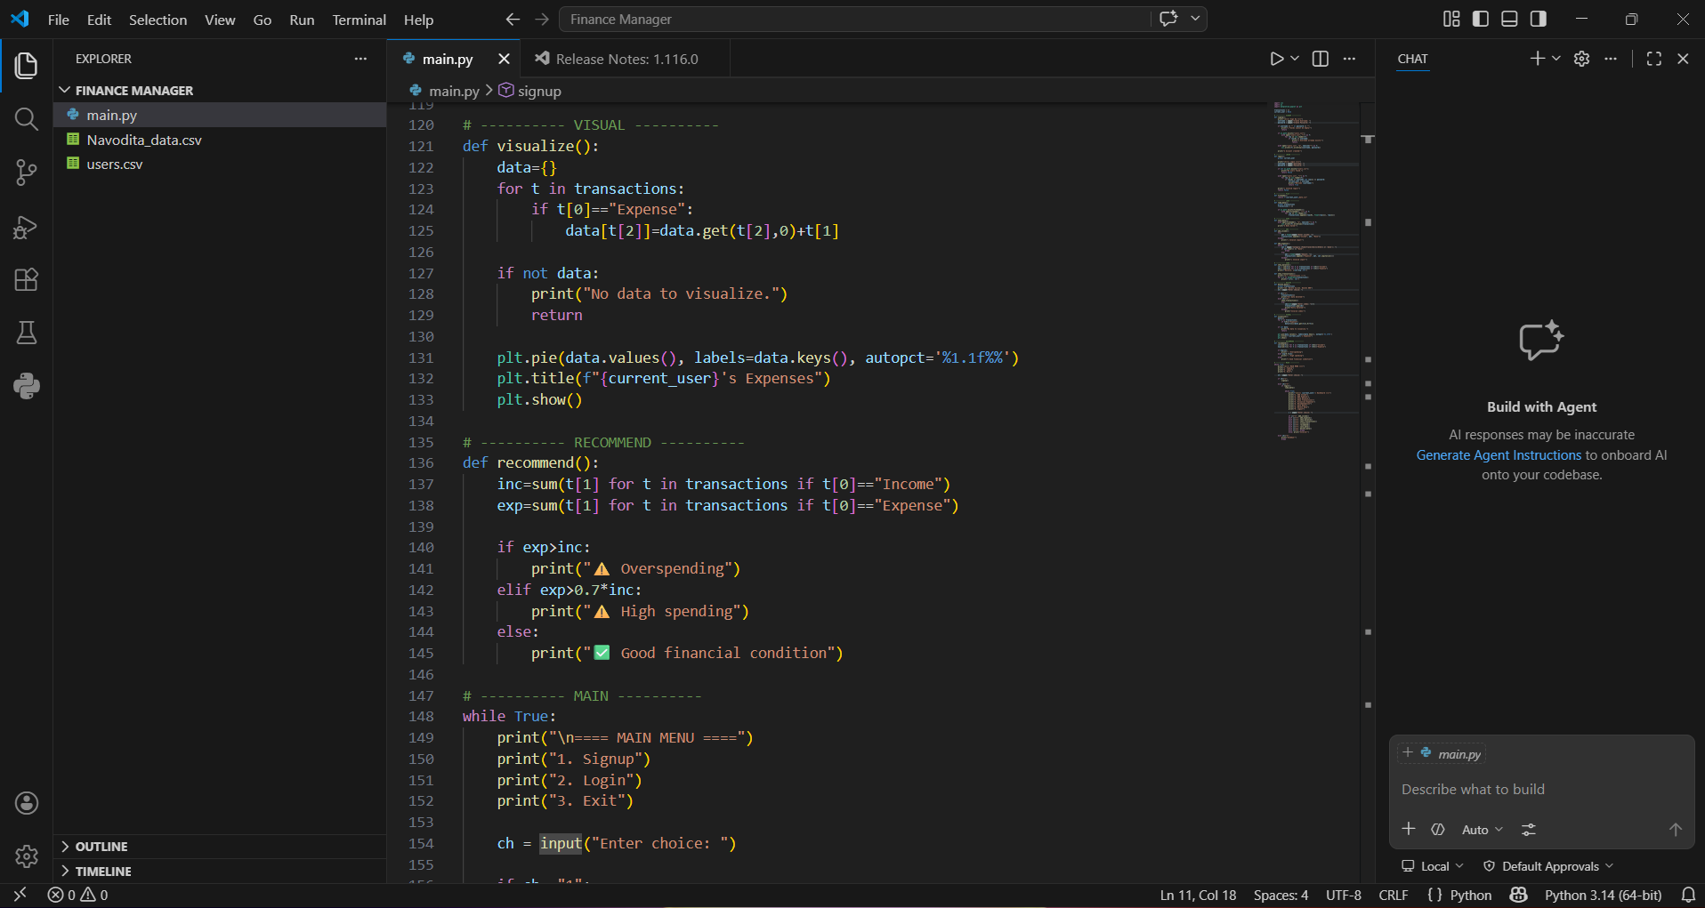
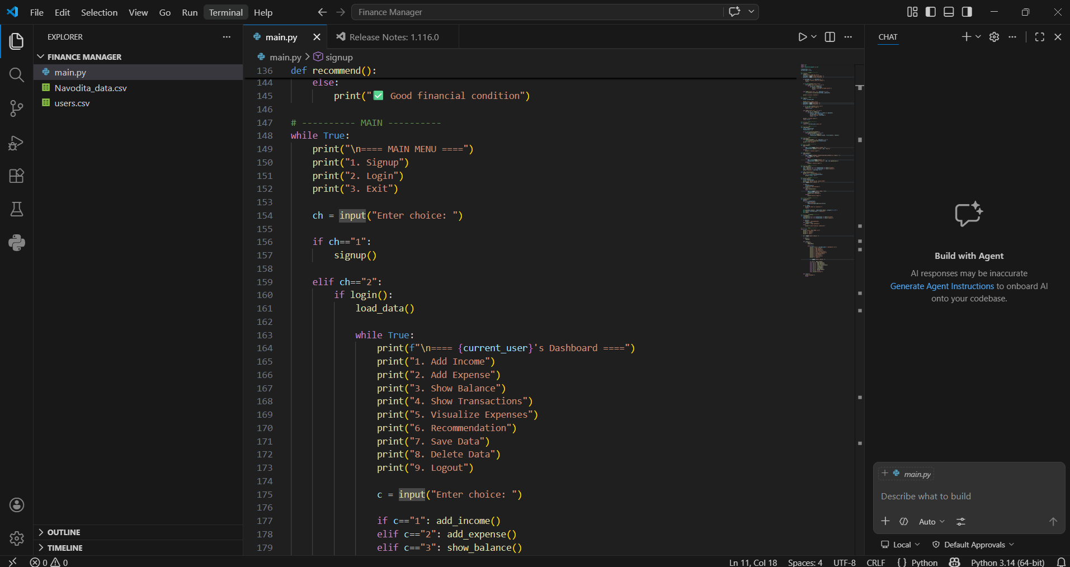

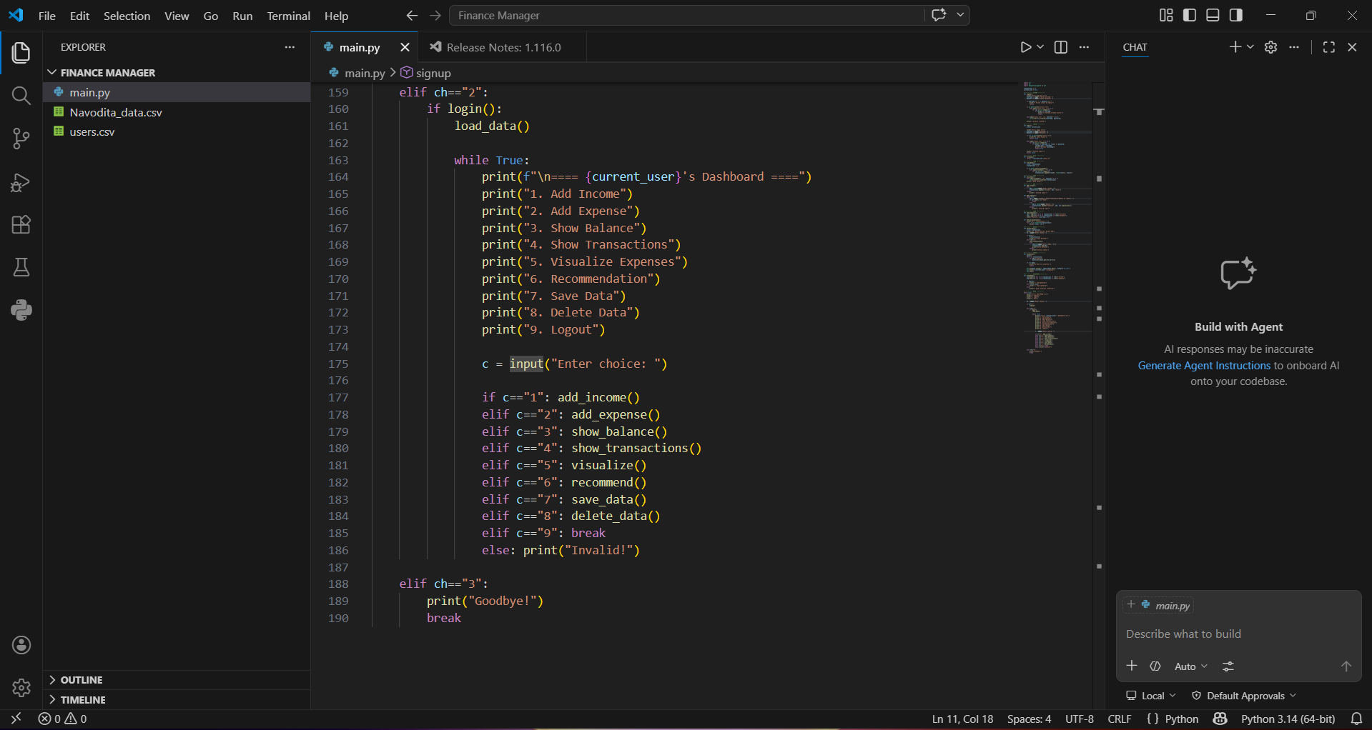

Result
The Personal Finance Manager was successfully implemented and tested. The system allows multiple users to manage their financial data independently. It accurately tracks income and expenses, generates visual insights through charts, and provides meaningful recommendations. The application is efficient, user-friendly, and meets the intended objectives.
Conclusion
This project demonstrates the practical implementation of Python programming concepts such as file handling, data structures, user authentication, and modular programming. It provides a real-world solution for managing personal finances and highlights the importance of data organization and analysis. The system is scalable and can be further enhanced with advanced features.

